Name: Tanmay Vig
Roll No.: 19BCS061
Class: B. Tech 3rd year
Q13: Write and execute a program in the assembly language of 8085 to find HCF of given two integers stored at a given location.
Tool used: 8085 simulator
Program:
Address | Assembly Code | Hex Code | Comments
0000 | LXI H, 2050H | 21  50  20 | Point reg pair HL to memory location 2050H (first Num)
0003 | MOV A,M | 7E | Move memory to Accumulator.
0004 | INX H | 23 | Increase the pointed location by 1
0005 | MOV B,M | 46 | Move memory to reg B
0006 | LOOP: CMP B | B8 | Compare B with A
0007 | JZ STORE | CA  17  00 | If both are equal then store the result
000A | JC EXG | DA  00  11 | If B>A, then swap values
000D | SUB B | 90 | If B<A, subtract B from A
000E | JMP LOOP | C3  06  00 | Jump to Label LOOP
0011 | EXG: MOV C,B | 48 | Move value in reg B to reg C
0012 | MOV B,A | 47 | Move value in Accumulator to reg B
0013 | MOV A,C | 79 | Move value in reg C to Accumulator
0014 | JMP LOOP | C3  06  00 | Jump to Label LOOP
0017 | STORE: STA 2052H | 32  52  20 | Store value of Accumulator in memory location 2052H
001A | HLT | 76 | Halt

Address | Data
2050H | 2D
2051H | 69
2052H | 0F

Input:
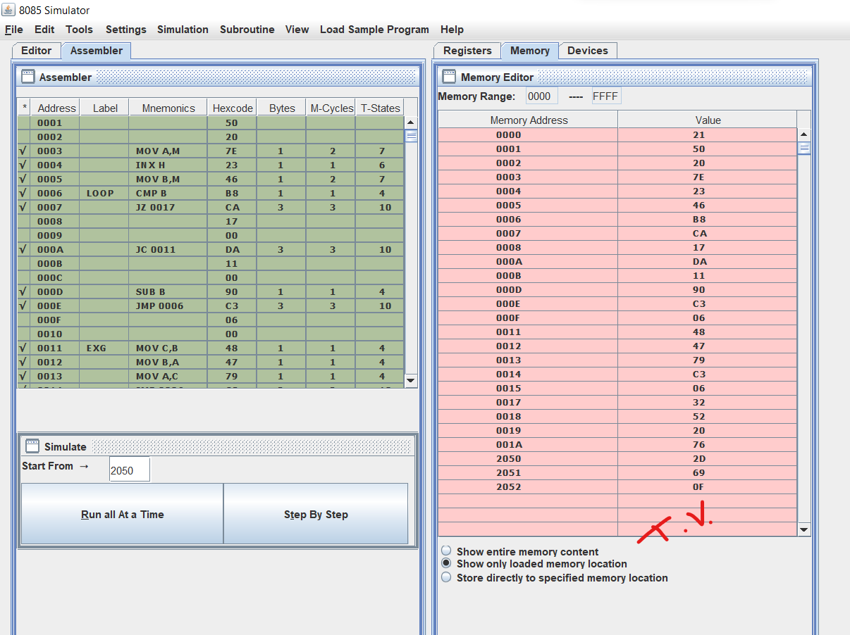
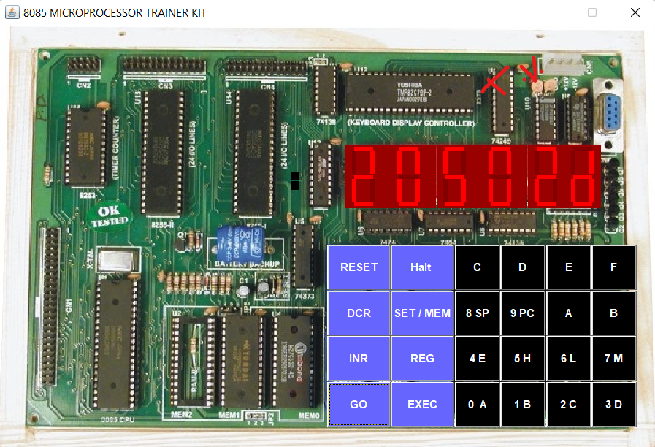
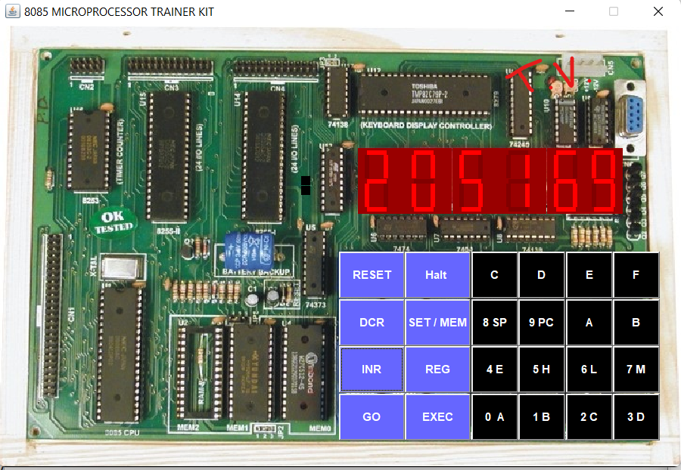

Output:
